Key Concepts and Tools Overview
Azure Portal
  - Intuitive and user-friendly graphical interface.
  - Ideal for exploration, monitoring, and ad-hoc management.
  - Not scalable or consistent for mass resource creation or automation.
  - Mouse-click based, prone to human error and inconsistent configurations.
Command-Line Interfaces (CLI): PowerShell with az module & Azure CLI
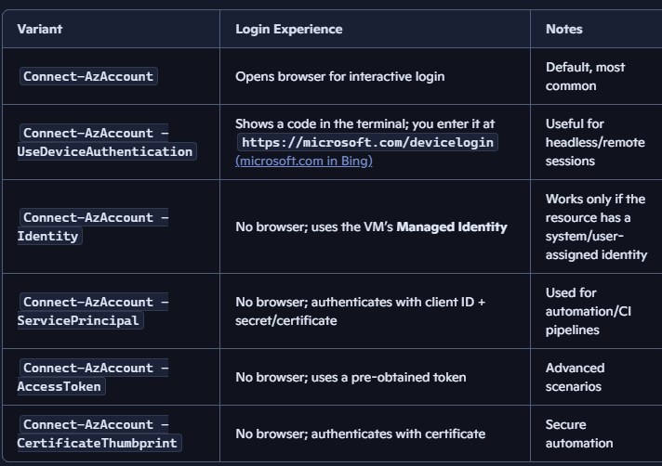
  - Both cross-platform (Windows, Linux, macOS). Imperative approach: scripts define how to perform actions step-by-step.
  - Great for automation of repetitive tasks (e.g., starting/stopping VMs).
  - Challenges with idempotency (applying an operation multiple times yields the same result as applying it once) and error handling in provisioning resources.
  - Both use Azure Resource Manager (ARM) control plane under the hood, authenticating via browser, device code, managed identity, or service principals.
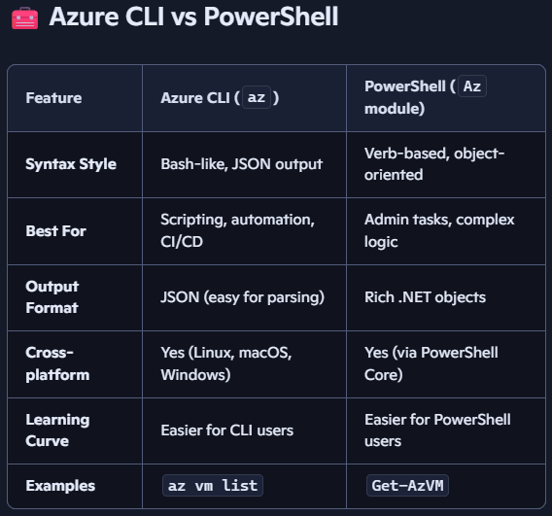
  - Once connected, PowerShell stores your Azure context, which includes: Subscription, Tenant, Account, Environment. Contexts let you manage multiple Azure environments (e.g., dev, prod) without re-authenticating. Avoid repeated logins, Quickly switch between subscriptions or tenants, Useful for consultants, admins, or multi-tenant setups.
  - Get-AzContext -ListAvailable # List all saved contexts
Set-AzContext -Name "SavillTech Prod" # Switch to a specific context
Rename-AzContext -TargetName "Dev" # Rename for clarity
  - # Azure CLI - can run inside a PowerShell (or other shell like cmd, bash) window but it’s a separate tool (written in python) from Azure PowerShell
az vm create --name MyVM --resource-group MyRG --image UbuntuLTS
  - # Azure PowerShell - A set of PowerShell cmdlets built on .NET (az module)
New-AzVM -Name MyVM -ResourceGroupName MyRG -ImageName UbuntuLTS
Azure Cloud Shell
  - Browser-based shell environment with PowerShell and Bash options.
  - Auto-authenticates with the logged-in Azure portal user.
  - Provides a ready-to-use environment with pre-installed Azure tools.
  - Useful for quick remote management without local setup.
Azure Resource Manager (Control Plane) and Resource Providers
  - All operations, regardless of interface, go through ARM. ARM enforces policies, role-based access control, and auditing. The consistent management layer for Azure resources.
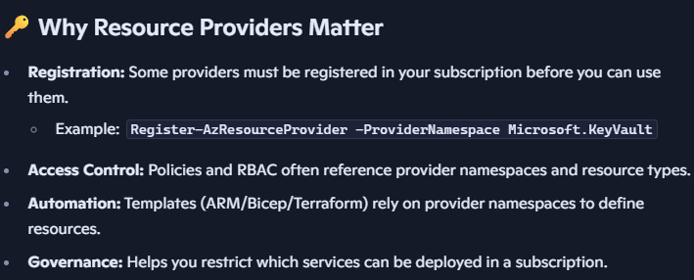
  - In Azure, Resource Providers (RPs) are the back-end services that supply and manage the different types of resources you can deploy. Every resource you create in Azure (VMs, storage accounts, databases, etc.) is backed by a specific resource provider. It exposes a set of resource types through the Azure Resource Manager (ARM). Each provider has a namespace (e.g., Microsoft.Compute, Microsoft.Storage, Microsoft.Network). Resource types are defined under these namespaces (e.g., Microsoft.Compute/virtualMachines, Microsoft.Storage/storageAccounts). When you deploy a resource, ARM routes the request to the correct provider.

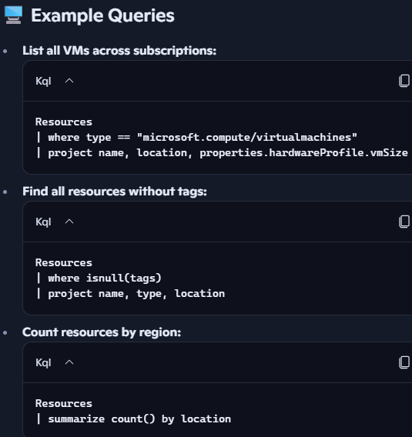
Azure Resource Graph
- A high-performance, read-only database for querying Azure resource inventory and metadata.
- Works across multiple subscriptions and management groups simultaneously. Built into the Azure portal, CLI, PowerShell, and REST API. Queries respect RBAC — you only see resources you have access to.
- Enables fast, scalable queries across large numbers of resources using Kusto Query Language.
- Avoids hitting ARM API rate limits and quotas. ARG also has own quota (15 queries every 5 seconds). Query results capped at 100,000 records per request (can page results).
- Supports change tracking (when a resource changed) and drift detection over a 7-14 day window.
- Used for inventory management, compliance checks, and identifying unused/wasted resources.

Imperative vs. Declarative Approaches
Aspect | Imperative (PowerShell, Azure CLI) | Declarative (ARM Templates, Bicep, Terraform)
Description | Commands specify how to perform each step | Specify what the desired end state should be
Idempotency | Difficult; errors if resource exists, requires complex checks | Idempotent; can run repeatedly without adverse effects
Error Handling | Complex; failed scripts need manual recovery | ARM handles creation, update, and drift detection (identifying when the actual state of your infrastructure no longer matches the desired state defined in your IaC templates)
Use Case | Automation of operational tasks (start/stop VMs, etc.) | Provisioning and managing infrastructure at scale
Consistency & Scalability | Less consistent, not scalable for large deployments | Highly consistent, scalable, and suitable for large infra

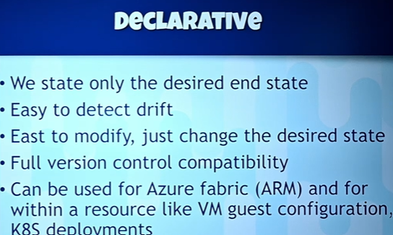
Declarative Infrastructure as Code (IaC)
ARM Templates
  - JSON files defining Azure resources and configurations. Verbose and complex; require careful handling of parameters and API versions. Support for deployment modes:
    - Incremental (default): Only ensures defined resources exist/are updated, leaves others intact.
    - Complete: Makes resource group exactly match template, deleting resources not defined in template (use with caution).
  - Can export existing resource configurations as ARM templates from the portal. Go to Resource group -> Deployments, and see the deployments been done under that RG, and can export their automatically generated ARM templates.
Bicep
  - A domain-specific language (DSL) for ARM templates, designed to be simpler and more readable.
  - Compiles (transpiles) to ARM JSON templates.
  - Provides better developer experience with Intellisense, modularization, and cleaner syntax.
  - Fully compatible with ARM deployments and tooling.
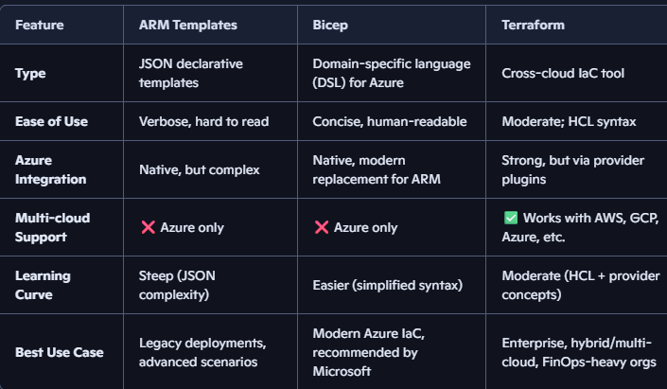
Terraform
  - Third-party open-source IaC tool supporting multiple cloud platforms (Azure, AWS, GCP, Kubernetes, VMware).
  - Uses Azure provider to manage Azure resources declaratively.
  - Suitable for multi-cloud/hybrid environments.
  - Microsoft collaborates closely with Terraform.
Template Specs
  - Azure resource that stores versioned templates in Azure itself.
  - Facilitates sharing, versioning, and access control of templates across teams and environments.
Parameter Files
  - Allow reuse of the same template across different environments (Dev, Test, Prod) by customizing resource names, SKUs, and settings without changing the template.

Version Control with Git
- Git provides distributed version control for managing infrastructure code and application source code.
- Enables branching, merging, rebasing, and collaboration on code changes.
- Integrates with tools like Visual Studio Code and remote repositories such as GitHub, Azure DevOps, Bitbucket, GitLab.
- Supports workflows with pull requests and code reviews to ensure code quality.
- Critical for tracking changes, enabling collaboration, and supporting DevOps pipelines.

DevOps and Continuous Integration/Continuous Delivery (CI/CD)
- DevOps is a cultural and procedural shift focusing on continuous incremental delivery of value through automation, collaboration, and feedback.
- Combines people, processes, and tooling to improve software delivery and operations.
- Uses version control, automated build, test, and deployment pipelines.
- Pipelines automate infrastructure provisioning (via IaC), application deployment, testing (unit, load, chaos testing), and monitoring.
- Emphasizes observability to understand usage and drive prioritization of features and fixes.
- Encourages microservices and containerization for consistent, repeatable deployments.
- Pipeline Example:
  - Code commit triggers pipeline.
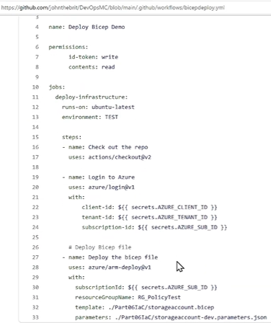
  - Build and test application and infrastructure code.
  - Deploy infrastructure (ARM/Bicep/Terraform) to target Azure environment.
  - Deploy application artifacts (containers, binaries).
  - Run additional tests (load, chaos).
  - Promote deployment through environments (dev → test → prod) with gates and approvals.
- GitHub Actions and Azure DevOps offer integrated CI/CD pipeline capabilities with native support for Azure authentication via OpenID Connect (OIDC), eliminating the need for storing secrets (using service principal created in entra, and using token exchange b/w github and azure) and improving security.

Summary of Recommendations
- Use Azure Portal primarily for exploration, troubleshooting, and monitoring, not for large-scale provisioning.
- Use PowerShell or Azure CLI for automating operational tasks but avoid for provisioning infrastructure at scale.
- Use declarative IaC templates (ARM/Bicep/Terraform) for provisioning and managing infrastructure consistently, enabling idempotency and drift detection.
- Use version control (Git) for all code, including infrastructure templates, to enable collaboration, traceability, and integration with pipelines.
- Implement DevOps pipelines to automate build, test, deployment, and monitoring processes for faster, safer, and more reliable delivery.
- Leverage Azure Resource Graph for fast, scalable querying of resource inventory and change analysis without hitting API limits.

Glossary of Terms
Term | Definition
ARM (Azure Resource Manager) | Azure’s control plane for resource management and deployment
IaC (Infrastructure as Code) | Managing infrastructure through declarative configuration files rather than manual steps
Declarative | Describes what the target state should be, not how to achieve it
Imperative | Specifies explicit steps to perform actions
Bicep | A DSL that compiles to ARM JSON, simplifying template authoring
Terraform | Open-source multi-cloud IaC tool with Azure provider
Git | Distributed version control system
DevOps | Cultural, procedural, and tooling approach for continuous delivery
CI/CD | Continuous integration and continuous deployment pipelines
Azure Resource Graph | Scalable query service for Azure resource inventory and metadata
Managed Identity | Azure service identity for authentication without secrets
OpenID Connect (OIDC) | Authentication protocol used for secure token exchange without secrets

Key Insights
- Declarative IaC is the preferred approach for provisioning Azure resources, enabling repeatable, idempotent deployments and drift detection.
- Imperative scripting is useful for automating operational tasks but less suited for provisioning infrastructure.
- Azure Resource Graph offers a fast, scalable, and quota-friendly method to query resource states and changes.
- Version control with Git is essential for managing infrastructure and application code collaboratively and safely.
- DevOps pipelines automate continuous delivery and improve software quality and responsiveness.
- Modern authentication flows, especially using managed identities and OIDC, enhance security and reduce secret management overhead.

